7 Content

7.1 Organisation of Content

Textiles Technology is an elective course designed to build upon Technology (Mandatory) Years 7–8 at Stage 5. Outcomes for Stage 4 have been included to allow flexibility for those schools who wish to offer the course in Years 7 and 8.

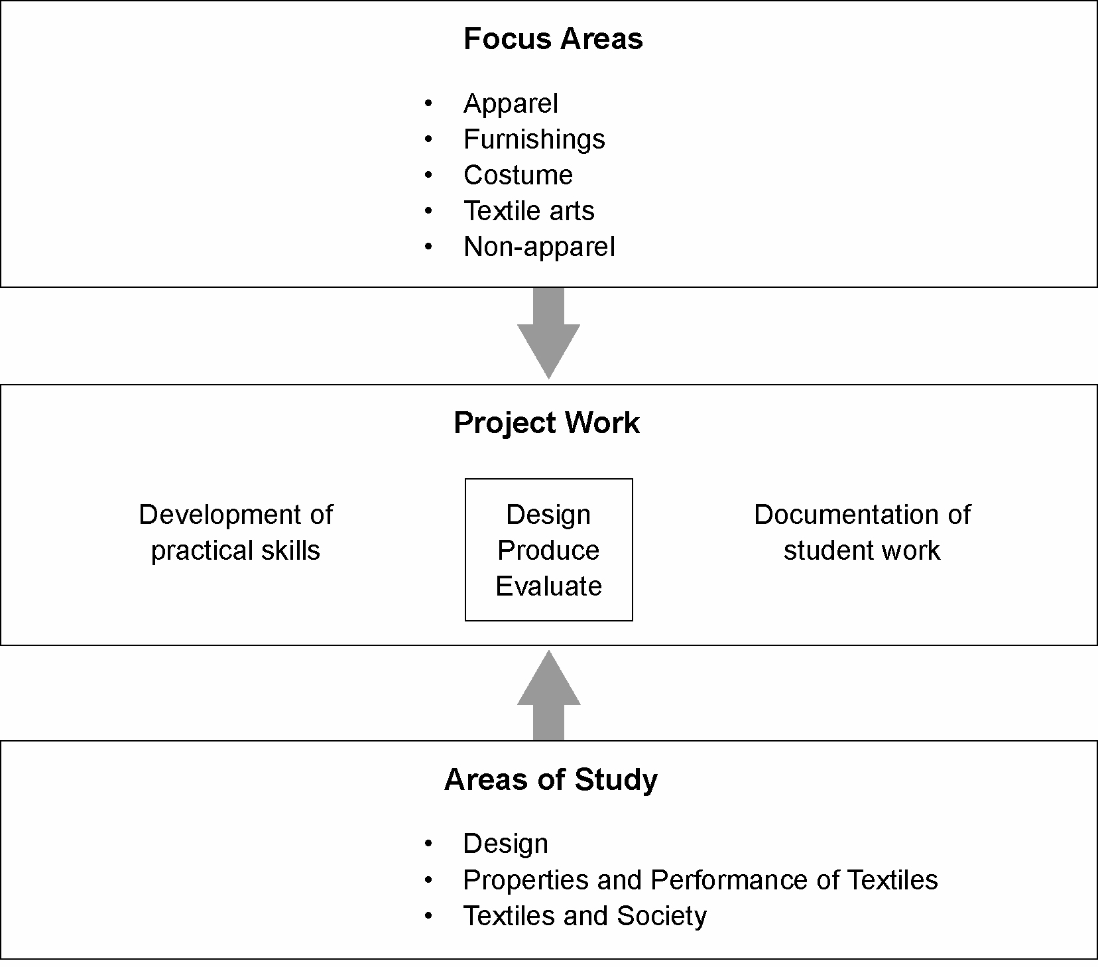

Units of Work
Project work forms the basis of every unit of work. Teachers will select a focus area as a starting point for the development of a unit of work. Appropriate content from project work and areas of study is integrated in creating units of work that meet student needs and interests.

A minimum of two units of work will be completed for the 100-hour course with each unit being developed from a different focus area. A minimum of four units of work will be completed for the 200-hour course, covering a minimum of three focus areas. Units of work in addition to this in either course may revisit focus areas. Units of work that revisit focus areas may be used for extension of student learning. Students can negotiate a project from a focus area of interest with the teacher and work independently.

Essential content
Students undertaking a 100-hour course must complete all content from project work and content from areas of study appropriate to the project and focus area selected. Teachers of the 100-hour course must ensure that all outcomes are addressed when selecting content from the areas of study. Students undertaking the 200-hour course must complete all content in each area of study and project work.

