7 Content

7.1 Organisation of Content

There are no prerequisites for the study of Information and Software Technology Years 7–10. It is an elective course which builds upon the knowledge, skills and experiences developed in the Technology (Mandatory) Years 7–8 Syllabus and through Information and Communication Technologies (ICT) content embedded across the curriculum.

This course integrates the study of core content within the context of options delivered through projects. The following diagram shows how the content is organised.

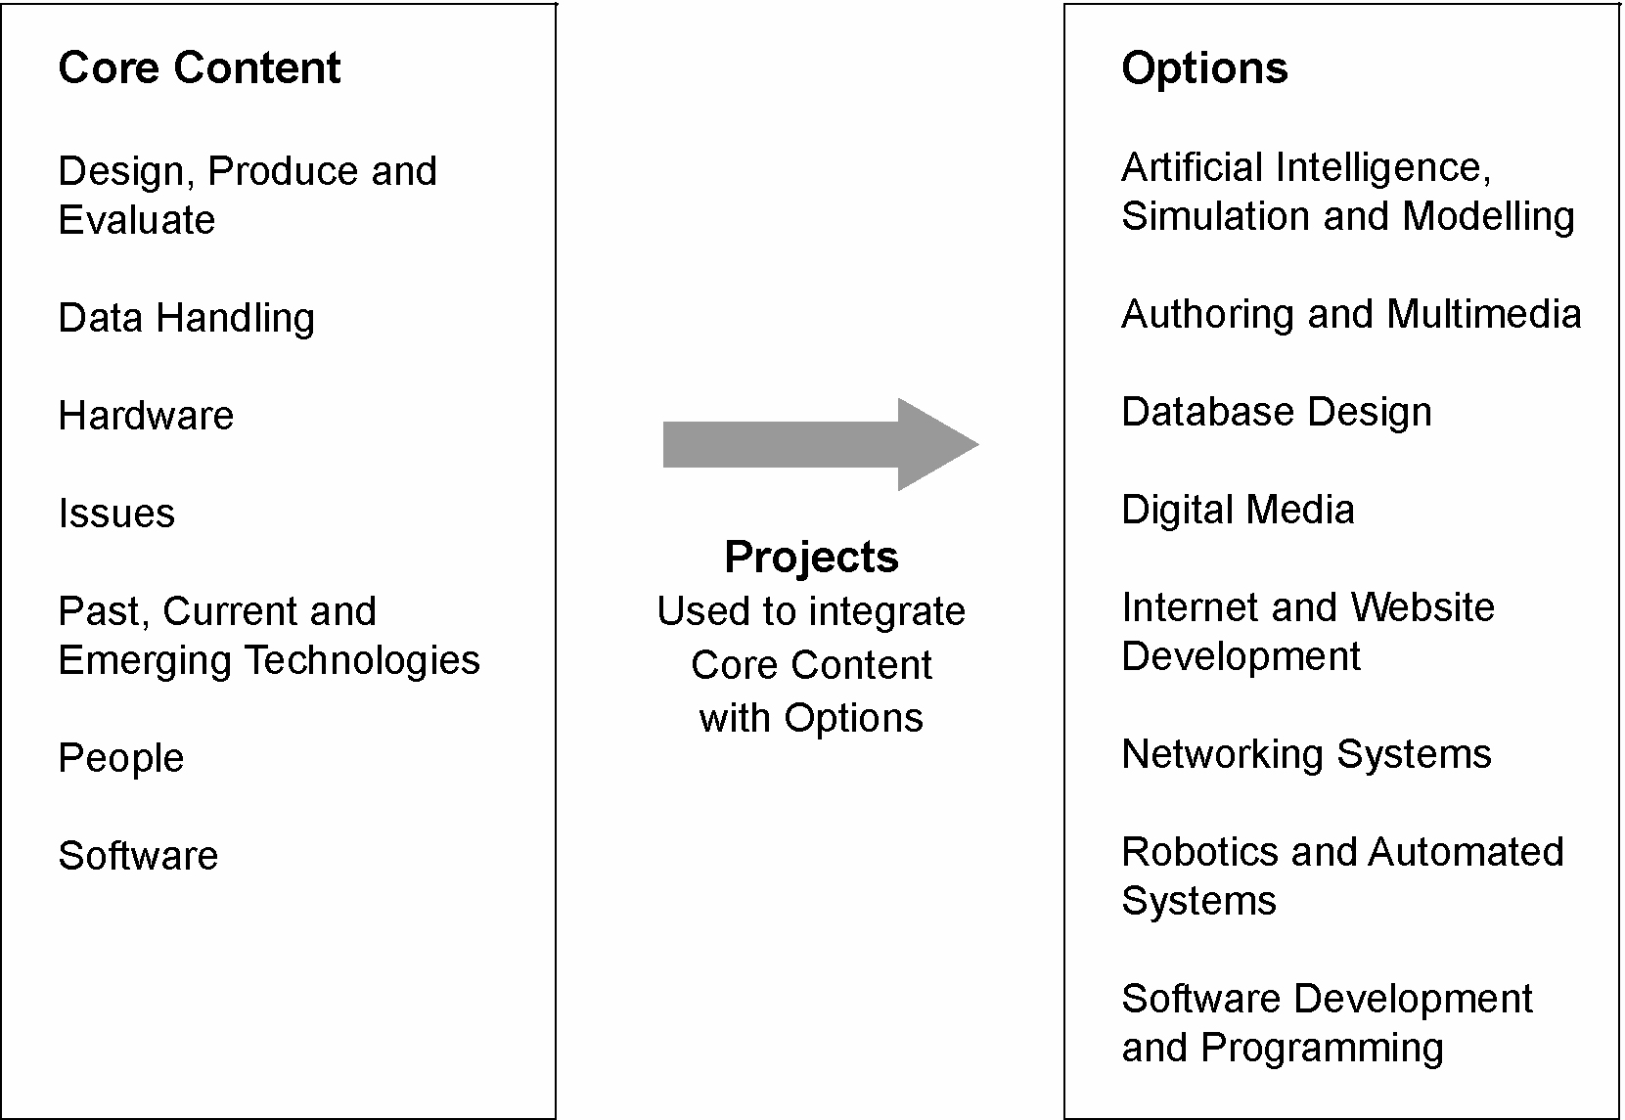

Course Structure
Information and Software Technology Years 7–10 may be studied as a 100-hour or as a 200-hour course. Not all the core content needs to be addressed in each project, but when creating a program of study for either course, all the content of the core and selected options will be addressed through projects over the duration of the course.

In a 100-hour course, students must be introduced to all core content within the study of a minimum of two options. Students will complete a minimum of two and a maximum of four projects.

Students undertaking a 200-hour course must complete all core content within the study of a minimum of four options. Students are expected to complete a minimum of four and a maximum of eight projects that provide increasingly sophisticated knowledge, understanding and skills related to the core content.

Essential content

Core
The core content cannot be taught in isolation: it must be integrated with options in the form of projects. Options should be planned to allow all of the core to be taught over the course of study. The core is divided into the following areas:
- Design, Produce and Evaluate
- Data Handling
- Hardware
- Issues
- Past, Current and Emerging Technologies
- People
- Software.

Options
Options allow for the integration and application of the core content. Teachers should select options that use school resources and consider student interest, teacher expertise and local community resources. The options are:
- Artificial Intelligence, Simulation and Modelling
- Authoring and Multimedia
- Database Design
- Digital Media
- Internet and Website Development
- Networking Systems
- Robotics and Automated Systems
- Software Development and Programming.

Projects
Projects include organised series of activities to design, produce and evaluate information and software technology solutions for an identified need or problem. The content for projects focuses on problem-solving, generating ideas, modelling, managing, communicating, collaborating and evaluating solutions. The project should be relevant to student needs and interests and address real-world problems. Content may be delivered in a variety of ways within the context of projects. It is not required that all learning be independent.

Documentation is used as a tool for student learning. It provides a means of recording
the student’s solution development and reflection.

