7 Content

7.1 Organisation of Content

Graphics Technology Years 7–10 is an elective course that builds on the knowledge, skills and experiences developed in the study of the Technology (Mandatory) Years 7–8 Syllabus.

The major emphasis of the Graphics Technology Years 7–10 Syllabus is on students being actively involved in the planning, development and production of quality graphical presentations. Students should be provided with broad experiences to develop knowledge, understanding and skills in a range of media and areas of application.

Modules
The Graphics Technology Years 7–10 Syllabus content is organised into two core modules and thirteen option modules. Core modules are designed to provide a broad understanding of the principles and techniques associated with producing graphical presentations in a variety of styles and formats. Option modules allow students to develop knowledge, understanding and skills in specific graphics-related fields. These fields may be selected to provide experiences appropriate to individuals’ abilities while catering for their special interests.

Core modules are structured in a sequential manner, with the knowledge, understanding and skills developed in Core Module 1 applied and enhanced in Core Module 2. Schools may deliver the core modules concurrently to maximise the utilisation of resources. Option modules may also be delivered concurrently to enable a thematic approach to the delivery of course content.

Each core module is designed to be taught in not less than 50 hours of planned learning experiences. Individual option modules will be delivered over 25 hours of planned learning experiences. Students will study four options in a 200-hour course. Option modules will be selected from a prescribed list.

Essential content
All modules provide essential content designed to develop knowledge, understanding and skills related to the four key areas of:
- graphics principles and techniques
- design in graphics
- planning and construction
- presentation.

Additional content
Students can move beyond the essential content in order to broaden and deepen their understanding and skills, and to extend their interest in particular aspects of Graphics Technology.

Additional content is suggested in Core Module 2 and in each option module.

Courses of study
Graphics Technology may be offered as a 100-hour or 200-hour course.

100-hour course
Students undertaking the 100-hour course are required to complete Core Module 1 and Core Module 2.

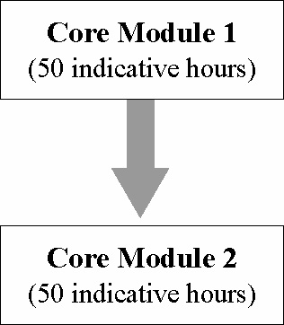

200-hour course
Students studying the 200-hour course are required to complete Core Modules 1 and 2 followed by the study of four option modules.

Students studying the 200-hour course may choose to undertake a Student Negotiated Project as one of the four options required. In this project they may choose to revisit an option for further investigation, undertake projects that combine aspects of a number of option modules or pursue an area of graphics with local or personal significance (eg marine, aeronautical or agricultural). The student will be required to negotiate the area(s) of study of the project
with the teacher.

