7 Content

7.1 Organisation of Content

Food Technology Years 7–10 is an elective course designed to build upon the Technology (Mandatory) course at Stage 5. Outcomes for Stage 4 have been included to allow flexibility for those schools who wish to offer the course in Years 7 and 8.

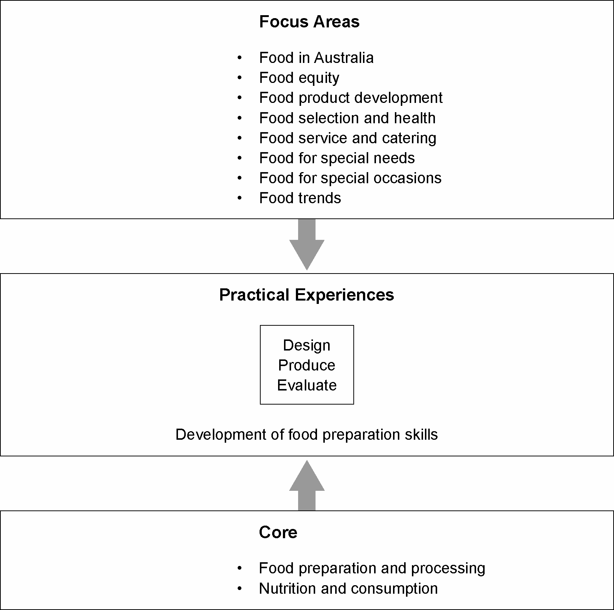

Units of Work
When creating a unit of work, relevant content will be selected from the core and integrated with all of the content of a selected focus area and appropriate practical experiences. During the study of each unit students will be required to undertake practical activities designed to refine and enhance student knowledge, understanding and skills. Units of work are developed to meet student needs and interests.

